* BREAKING



Red Sox 10, Braves 8, Final



**Nonprofit proposes housing**

**development in Mattapan**

**By Tim Logan** Globe Staff, October 19, 2015, 7:16 p.m.

A Mattapan-based community development agency is proposing the largest housing development the neighborhood has seen in five years.



Caribbean Integration Community Development filed plans with the Boston Redevelopment Authority last week to build a 71-unit affordable housing complex outside Mattapan Square at the intersection of Cummins Highway and Regis Road. The project would put townhomes and a four-story apartment building on a long-vacant parcel of city-owned land two blocks from the Mattapan MBTA station.

The neighborhood group is partnering with veteran non-profit housing developer Planning Office for Urban Affairs, Inc., and the project is being financed by the AFL-CIO's Housing Investment Trust, according to a letter to the BRA. Developers intend to file more detailed plans next month and, pending city approval, hope to start construction within a year.

Advertisement



It would be the biggest housing development since 2010 in a neighborhood on the southern edge of Boston that has largely missed out the city's building boom.

**BOSTON GLOBE VIDEO**

[Tim Logan can be reached at tim.logan@globe.com. Follow him on Twitter](mailto:TimLogancanbereachedattim.logan@globe.com.FollowhimonTwitter) at @bytimlogan.

**Show comments**

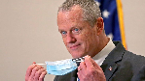

2:23

Baker announces ‘VaxM SHARE

Governor Charlie Baker announced residents who are fully vaccinated against COVID-19 will have the chance to win $1 million in a special Lottery sweepstakes. (Photo by Matt Stone/Boston Herald via AP)

**s ns’**

**rd**

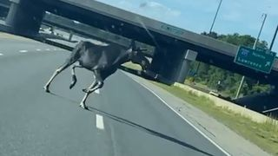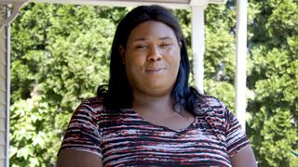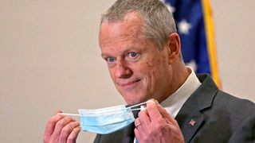

**Baker Moose What announce spotted Black ‘VaxMillio on liberation lottery Route 3 means program in to me:**

**Chelmsfo Athena**

**Vaughn**

**NOW PLAYING**

**MOST POPULAR ON BOSTONGLOBE.COM**

1. A treasure map for an American tyrant
2. Baker announces ‘VaxMillions’ lottery program, offering $1 million cash prizes to boost vaccination rates
3. 5 things to know about the VaxMillions lottery sweepstakes in Mass.
4. America's blind spot: Thousands of drivers shouldn't be licensed
5. Death penalty should be reinstated for Tsarnaev in Boston Marathon bombings case, Biden administration tells Supreme Court
6. Message in a bottle, tossed into the sea in Rhode Island, found in Azores
7. The downside of ditching masks: the return of colds, flu
8. How white supremacy weaponizes ignorance
9. I got the Johnson & Johnson vaccine. The pause makes me believe in it more.
10. A Milton gay couple was harassed anonymously for years. Then a piece of handwriting unraveled the mystery



**VIEWS FROM OUR COLUMNISTS**

**YVONNE ABRAHAM**

Energy efficiency is a low- hanging fruit to combat climate change. So why can’t everyone get access to it?

**KEVIN CULLEN**

Bill Bratton on American policing and the challenge facing the Boston Police Department

**THOMAS FARRAGHER**

A salute across the ages to an old squad leader

**SHIRLEY LEUNG**

A working mother’s manifesto: Pandemic provides a once-in-a- generation chance to course correct how we work

**JENEÉ OSTERHELDT**

Juneteenth and the meaning of Black liberation in Boston

**ADRIAN WALKER**

‘The best Boston movie no one’s ever seen’: ‘Blue Hill Avenue’ at 20

**MORE ON GLOBE.COM**

# SPONSORED BY: PHILIP MORRIS INTERNATIONAL

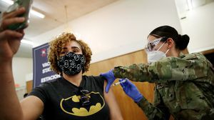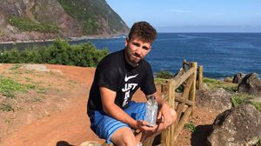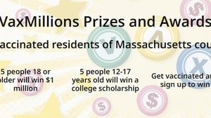

## By going remote, clinical trials are becoming more patient- friendly

The pandemic pushed research to go virtual. Now, decentralized trials are reaching more people and driving progress.

## 5 things to know about the VaxMillions lottery sweepstakes in Mass.

Here are five things you should know about the VaxMillions program, which will make some lucky winners living proof that trusting the science really does pay.

# RI NEWS

## Message in a bottle, tossed into the sea in Rhode Island, found in Azores

The note was written in 2018 by a 13- year-old who was visiting family in Rhode Island.

# RED SOX 10, BRAVES 8

## Red Sox hit four homers to put away Braves

It didn’t take long for Rafael Devers to make his presence known with a three- run homer in the first inning.

# OPINION

## I got the Johnson & Johnson vaccine. The pause makes me believe in it more.

The worst thing that could happen now is for the recommendation by the FDA and CDC to pause the vaccine’s administration to spur a new wave of vaccine hesitancy.

## Baker announces ‘VaxMillions’ lottery program, offering $1 million cash prizes to boost vaccination rates

State officials on Tuesday said residents who are fully vaccinated against COVID-19 will have the chance to win $1 million in a special Lottery sweepstakes.

## Lawmakers reach compromise on restoring pandemic era- policies including to-go cocktails, outdoor dining

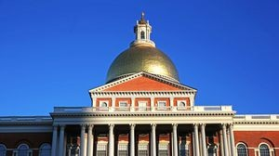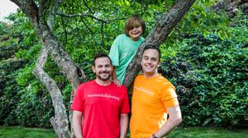

A House and Senate conference committee has reached a compromise to extend several pandemic-era policies that expired earlier in the day, legislative leaders said Tuesday night.

## A Milton gay couple was harassed anonymously for years. Then a piece of handwriting unraveled the mystery

After years of dead ends, police recently were led to a suspect, a neighbor who lives a few doors from the couple and had shared hellos, waves, and casual conversation with them.

## A treasure map for an American tyrant

Donald Trump exposed weaknesses that a would-be dictator could exploit to end our democracy. It’s now up to lawmakers, voters, and public officials to prevent that from happening.

## ‘Boo Boo’ the South Shore Bear captured on video roaming in Duxbury

Duxbury police said on Twitter that a resident living on Elm Street spotted Boo Boo in the backyard around 8:30

a.m. Tuesday, eating birdseed.

**METRO SPORTS BUSINESS & TECH OPINION**

WELCOME, JOHN

**TODAY'S PAPER**

**Check out this week's**

**virtual events**

RSVP now

**LAWMAKERS STRIKE DEAL TO RESTORE PANDEMIC-ERA POLICIES, INCLUDING EVICTION PROTECTIONS, TO-GO COCKTAILS**

### MOST READ IN THIS SECTION

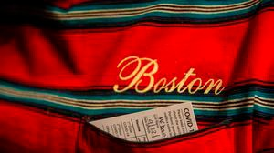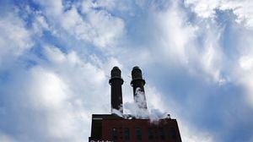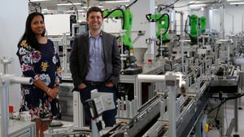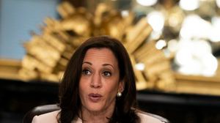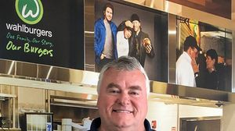

**Why does the Johnson & Johnson vaccine work against variants? A new study suggests an answer**

**Targeted by short sellers, DraftKings gets aid from Reddit’s online brigade**

**A power play? Steam plant owner aims to decarbonize downtown with huge building project**

**INNOVATION ECONOMY**

**Life sciences is poised to be Boston’s dominant industry. Has the area become the Silicon Valley of biotech?**

**ON THE STREET**

**Photos: A look back at Revere, America’s first public beach**

**TALKING POINTS**

**Harris announces**

**$1.25 billion to community lenders**

**US and EU agree to suspend feud over aid for Airbus and Boeing**

**These Massachusetts organizations received donations from MacKenzie Scott**

**New Wahlburgers CEO looks to expand fast-casual concept**

**FOLLOW US**

### SUBSCRIBE NOW MY ACCOUNT CONTACT MORE



Digital Access Home Delivery

Gift Subscriptions

Log In

Manage My Account Customer Service

Help & FAQs Globe Newsroom

Advertise

Newsletters / View The EPaper /

Order Back Issues / News In Education / Search The Archives / Privacy Policy / Terms Of Service / Terms Of Purchase / Work At Boston Globe Media /

Do Not Sell My Personal Information

©2021 Boston Globe Media Partners, LLC